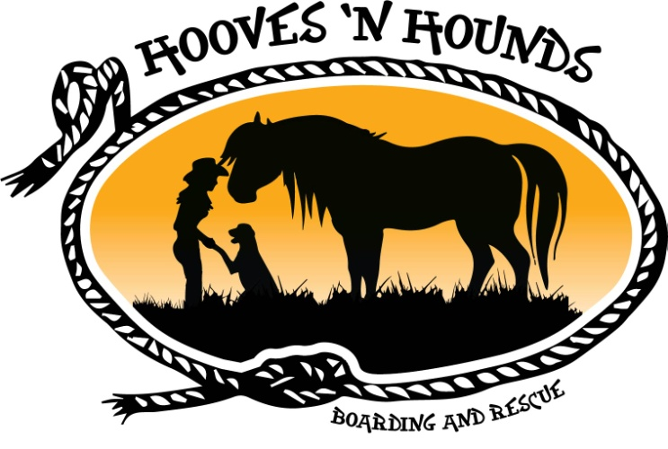
Adoption Application
Welcome to Hooves ‘N Hounds Boarding and Rescue where the broken and forgotten mend. Please fill out this detailed application which will highlight why you will make an exceptional horse owner by providing a safe and loving home for one of our rescued horses.
Applicant
Name:____________________________________________________
Address:___________________________________________________
City/Province/State___________________________________________
Postal Code/Zip___________________________________________________
Home Phone:_______________ Cell Phone:__________________
Do you Rent? ___ Own?___ Live with parents?___
Landlords name?________________Landlords Phone?______________

Horse Information
What horse are you applying to adopt?_________________________
What will the horse be used for?_______________________________
What are your goals for you and this horse?__________________________________________________________________________________________________________________
Will the horse be kept on your property?__________________________
If yes, describe the area/space/shelter/access to water___________________________________________________________________________________________________________________

If no, please list the address and description of the boarding facility where you plan to keep the horse?__________________________________________________________________________________________________________________
Do you currently own any other horses? ______________
If yes, please describe your horse(s)_________________________________________________________________________________________________________________
If no, is this your first horse?_________________________
Are there other animals on the property where you will be keeping the horse?_______________
If yes, how many__________ and please list all other animals staying on the property with the horse__________________________________________________________________________________________________________________
Is pasture available? _____________ How many acres?_______________
Will the horse have access to fresh water 24 hours a day?_____________
Please describe your Feed Program_________________________________________________________________________________________________________________
Will you be feeding grain? _____________
Please explain__________________________________________________________________________________________________________________
What type of fencing do you have?_______________________________________________________
Have you ever been issued a warning/citation for Humane Violations against animals?___________
If yes, please explain__________________________________________________________________________________________________________________
Please explain your level of experience with horses/riding_________________________________________________________________________________________________________________________________________________________________________
Please explain why you would like to adopt a rescue horse?______________________________________________________________________________________________________________________________________________________________________________

Are you willing to sign a “First Right of Refusal” contract? ______________________
If you own an animal now, who is:
Your Veterinarian? Name___________________Phone______________
Your Ferrier? Name_______________________Phone_______________
If you don’t own an animal right now, who will be:
Your Veterinarian? Name____________________Phone______________
Your Ferrier? Name________________________Phone_______________

Please provide 2 references (other than family)
- Name________________________ Relationship____________________________
Phone number ______________________________________________
- Name________________________ Relationship____________________________
Phone number ______________________________________________

I/We certify that all the information contained herein is true and correct.

Signature

____________________________________________________________
Signature Date

